

Machine Learning Internal Question Paper Scheme and Solution

USN |  |  |  |  |  |  |  |  |  |  |  |  |  |  |  | 
Internal Assessment Test 1 - Mar 2026
Sub: | Machine Learning |  |  |  |  |  |  |  |  |  |  |  |  |  |  | Sub Code: | BCS602 | Branch: |  | ISE
Date: | 03/03/2026 |  |  |  | Duration: |  |  | 90 min |  |  | Max Marks: |  |  |  | 50 | Sem/Sec: | VI / A, B & C |  |  | OBE
Answer any FIVE FULL Questions |  |  |  |  |  |  |  |  |  |  |  |  |  |  |  |  |  |  | MAR KS | CO | RBT
1a | Tom Mitchell’s definition of machine learning. List out the factors that drive the popularity of machine learning. |  |  |  |  |  |  |  |  |  |  |  |  |  |  |  |  |  | [04] | CO1 | L1
1b | Explain Supervised, Unsupervised, and semi-supervised Learning with examples |  |  |  |  |  |  |  |  |  |  |  |  |  |  |  |  |  | [06] | CO1 | L2
2a | Explain in detail the machine learning process model with the process flow diagram |  |  |  |  |  |  |  |  |  |  |  |  |  |  |  |  |  | [05] | CO1 | L2
2b | Explain Big Data Analytics and Types of Analytics with examples |  |  |  |  |  |  |  |  |  |  |  |  |  |  |  |  |  | [05] | CO1 | L2
3 | 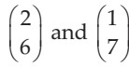  Let the data points be . Apply PCA and find the transformed data. Apply reverse and prove that PCA Works. |  |  |  |  |  |  |  |  |  |  |  |  |  |  |  |  |  | [10] | CO2 | L3
4a | Write the Find-S algorithm with a solved example for the same, and specify the limitations of Find-S. |  |  |  |  |  |  |  |  |  |  |  |  |  |  |  |  |  | [07] | CO2 | L3
4b | Do the stem and Leaf plot for the following English Marks  {38, 53, 63, 82, 88, 83, 85,92} |  |  |  |  |  |  |  |  |  |  |  |  |  |  |  |  |  | [03] | CO2 | L3
5a | Apply the Candidate Elimination algorithm for the training dataset below, which consists of 6 instances. Show the updated S and G boundaries after processing every instance.  Sky AirTemp Humidity Wind Water Forecast EnjoySport Sunny Warm Normal Strong Warm Same Yes Sunny Warm High Strong Warm Same Yes Rainy Cold High Strong Warm Change No Sunny Warm High Strong Cool Change Yes |  |  |  |  |  |  |  |  |  |  |  |  |  |  |  |  |  | [08] | CO2 | L3
5b | Sorted data for price(in dollars): 2, 6, 7, 9, 13, 20, 21, 24, 30. Apply various Binning Techniques |  |  |  |  |  |  |  |  |  |  |  |  |  |  |  |  |  | [02] | CO2 | L3
6a | Write the definition for the K-Nearest Neighbour (KNN) algorithm. Consider the following student performance training dataset:  S.No CGPA Assessment Project Result  - 9 88 9 Pass  - 8.3 75 8 Pass  - 7.9 73 7 Pass  - 5.6 45 5 Fail  - 7 53 6 Fail  - 6.6 55 5 Fail  - 8.6 82 8 Pass  - 5.8 48 4 Fail  Using the K-Nearest Neighbour (KNN) algorithm with K = 3, classify the following test instance: (5.8,90,8) |  |  |  |  |  |  |  |  |  |  |  |  |  |  |  |  |  | [08] | CO3 | L3
6b | Write the Nearest centroid classifier algorithm |  |  |  |  |  |  |  |  |  |  |  |  |  |  |  |  |  | [02] | CO3 | L1
CI CCI HOD

USN
Internal Assessment Test 1 - Mar 2026
Sub: | Machine Learning |  |  |  |  |  |  |  |  |  |  |  |  |  |  | Sub Code: | BCS602 | Branch: |  | ISE
Date: | 03/03/2026 |  |  |  | Duration: |  |  | 90 min |  |  | Max Marks: |  |  |  | 50 | Sem/Sec: | VI / A, B & C |  |  | OBE
Answer any FIVE FULL Questions and Answers |  |  |  |  |  |  |  |  |  |  |  |  |  |  |  |  |  |  | MAR KS | CO | RBT
1a | Tom Mitchell’s definition of machine learning. List out the factors that drive the popularity of machine learning.  Scheme: -  Definition: - 1 Marks  Factors: - 1*3=3 Marks  Ans: A computer program is said to learn from experience (E) with respect to some task (T) and performance measure (P), if its performance at task T, as measured by P, improves with experience E.  Factors driving popularity of ML:  - High volume of available data to manage: Big companies such as Facebook, Twitter, and YouTube generate huge amount of data that grows at a phenomenal rate. It is estimated that the data approximately gets doubled every year.  - Second reason is that the cost of storage has reduced. The hardware cost has also dropped. Therefore, it is easier now to capture, process, store, distribute, and transmit the digital information.  - Third reason for popularity of machine learning is the availability of complex algorithms now. Especially with the advent of deep learning, many algorithms are available for machine learning. With the popularity and ready adaption of machine learning by business organizations, it has become a dominant technology trend now. |  |  |  |  |  |  |  |  |  |  |  |  |  |  |  |  |  | [04] | CO1 | L1
1b | Explain Supervised, Unsupervised, and semi-supervised Learning with examples  Scheme: -  Definition & Explanation: -2*3=6 Marks  Ans: Supervised Learning: Uses labeled data. Explain the example: Email spam classification.  - Supervised algorithms use labelled dataset. As the name suggests, there is a supervisor or teacher component in supervised learning.  - A supervisor provides labelled data so that the model is constructed and generates test data.  - In supervised learning algorithms, learning takes place in two stages.  - In layman terms, during the first stage, the teacher communicates the information to the student that the student is supposed to master.  - The student receives the information and understands it.  - During this stage, the teacher has no knowledge of whether the information is grasped by the student.  Unsupervised Learning: Uses unlabeled data. Explain the example: Customer segmentation using clustering.  - The second kind of learning is by self-instruction.  - There are no supervisor or teacher components.  - In the absence of a supervisor or teacher, self-instruction is the most common kind of learning process.  - This process of self-instruction is based on the concept of trial and error. |  |  |  |  |  |  |  |  |  |  |  |  |  |  |  |  |  | [06] | CO1 | L2

- Here, the program is supplied with objects, but no labels are defined.
- The algorithm itself observes the examples and recognizes patterns based on the principles of grouping.
- Grouping is done in ways that similar objects form the same group.
- Cluster analysis and Dimensional reduction algorithms are examples of unsupervised algorithms.

Semi-Supervised Learning: Combination of labeled and unlabeled data. Explain the example: Image classification with few labeled samples.
- There are circumstances where the dataset has a huge collection of unlabelled data and some labelled data.
- Labelling is a costly process and difficult to perform by the humans.
- Semi-supervised algorithms use unlabelled data by assigning a pseudo-label.
- Then, the labelled and pseudo-labelled dataset can be combined.
2a | Explain in detail the machine learning process model with the process flow diagram  Scheme: -  Diagram: - 3 Marks  Explanation: -3 Marks  Ans:  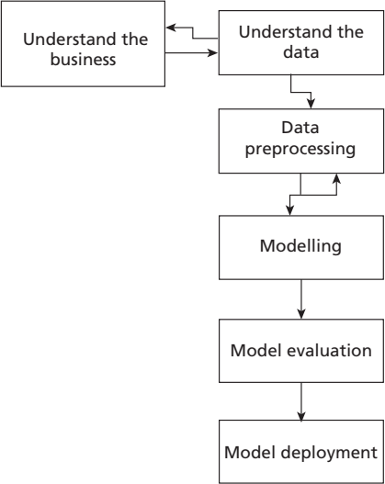  - 1. Understanding the business – This step involves understanding the objectives and requirements of the business organization. Generally, a single data mining algorithm is enough for giving the solution. This step also involves the formulation of the problem statement for the data mining process.  - 2. Understanding the data – It involves the steps like data collection, study of the characteristics of the data, formulation of hypothesis, and matching of patterns to the selected hypothesis.  - 3. Preparation of data – This step involves producing the final dataset by cleaning the raw data and preparation of data for the data mining process. The missing values may cause problems during both training and testing phases. Missing data forces classifiers to produce inaccurate results. This is a perennial problem for the classification models. Hence, suitable strategies should be adopted to handle the missing data  - 4. Modelling – This step plays a role in the application of data mining  algorithm for the data to obtain a model or pattern. | [05] | CO1 | L2

- 5. Evaluate – This step involves the evaluation of the data mining results using statistical analysis and visualization methods. The performance of the classifier is determined by evaluating the accuracy of the classifier. The process of classification is a fuzzy issue. For example, classification of emails requires extensive domain knowledge and requires domain experts. Hence, performance of the classifier is very crucial.
- 6. Deployment – This step involves the deployment of results of the data mining algorithm to improve the existing process or for a new situation.
2b | Explain Big Data Analytics and Types of Analytics with examples  Scheme: -  Definition=1 Marks  Types: -1*4=4 Marks  Ans: Big Data Analytics refers to the process of analyzing extremely large and complex datasets to discover hidden patterns, correlations, trends, and useful insights that support better decision-making. With the growth of digital technologies, organizations generate massive volumes of structured and unstructured data from sources such as social media, sensors, transactions, and web applications. Big Data Analytics uses advanced tools and techniques to process this data efficiently.  Big Data Analytics and Types of Analytics  The primary aim of data analysis is to assist businesses and organizations in making better decisions. Data analytics involves examining data to extract useful information, identify patterns, and support decision-making.  There are four main types of data analytics:  - Descriptive Analytics  Descriptive analytics focuses on describing the main features of collected data. It summarizes historical data to understand what has happened in the past. It uses statistical measures such as mean, median, percentage, and frequency to present data in a meaningful way.  - Diagnostic Analytics  Diagnostic analytics deals with the question “Why did it happen?”. It is also known as causal analysis. This type of analytics identifies the causes and relationships behind events by examining patterns and correlations in data.  - Predictive Analytics  Predictive analytics deals with forecasting future outcomes based on historical data. It answers the question “What will happen in the future?”. It uses statistical models and machine learning algorithms to identify patterns and predict future trends.  - Prescriptive Analytics  Prescriptive analytics suggests the best course of action to take. It goes beyond prediction and provides recommendations for decision-making. It helps organizations plan effectively and reduce risks by suggesting optimal solutions. |  | [05] | CO1 | L2

3 | Let the data points be . Apply PCA and find the transformed data. Apply reverse and prove that PCA Works.  Scheme: -  Step by step solution:- 10 Marks  Ans:  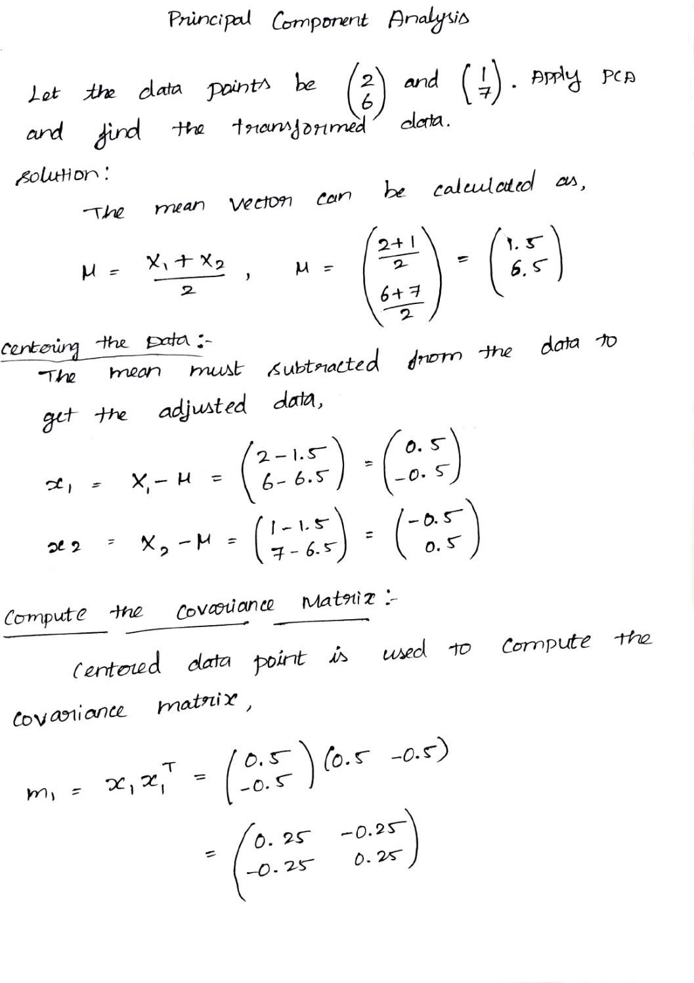 | [10] | CO2 | L3

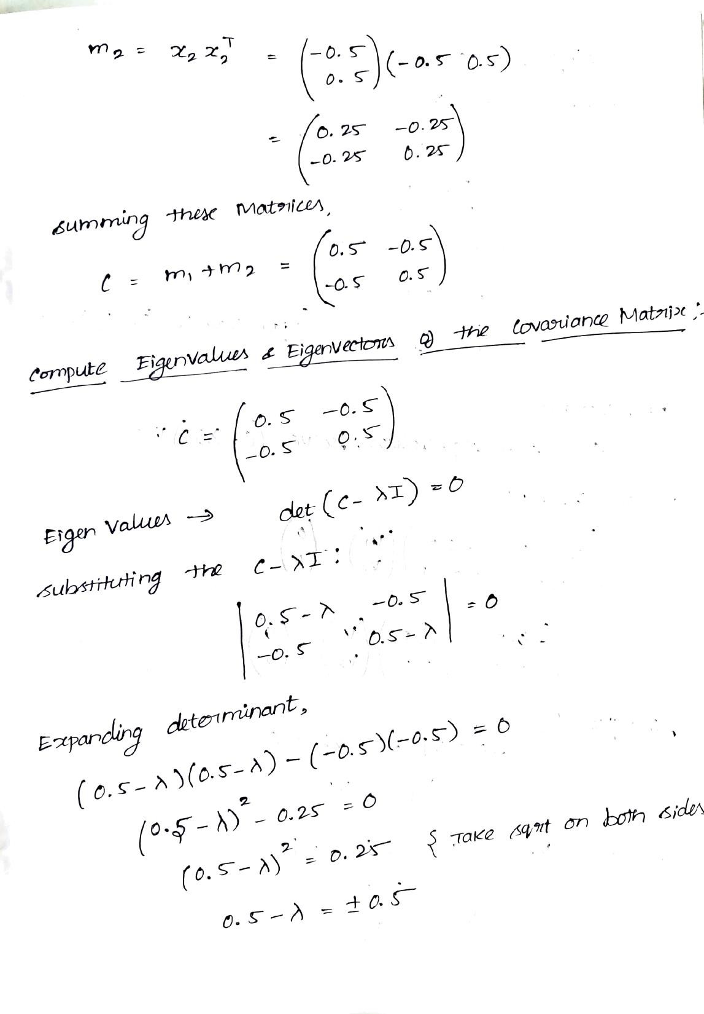

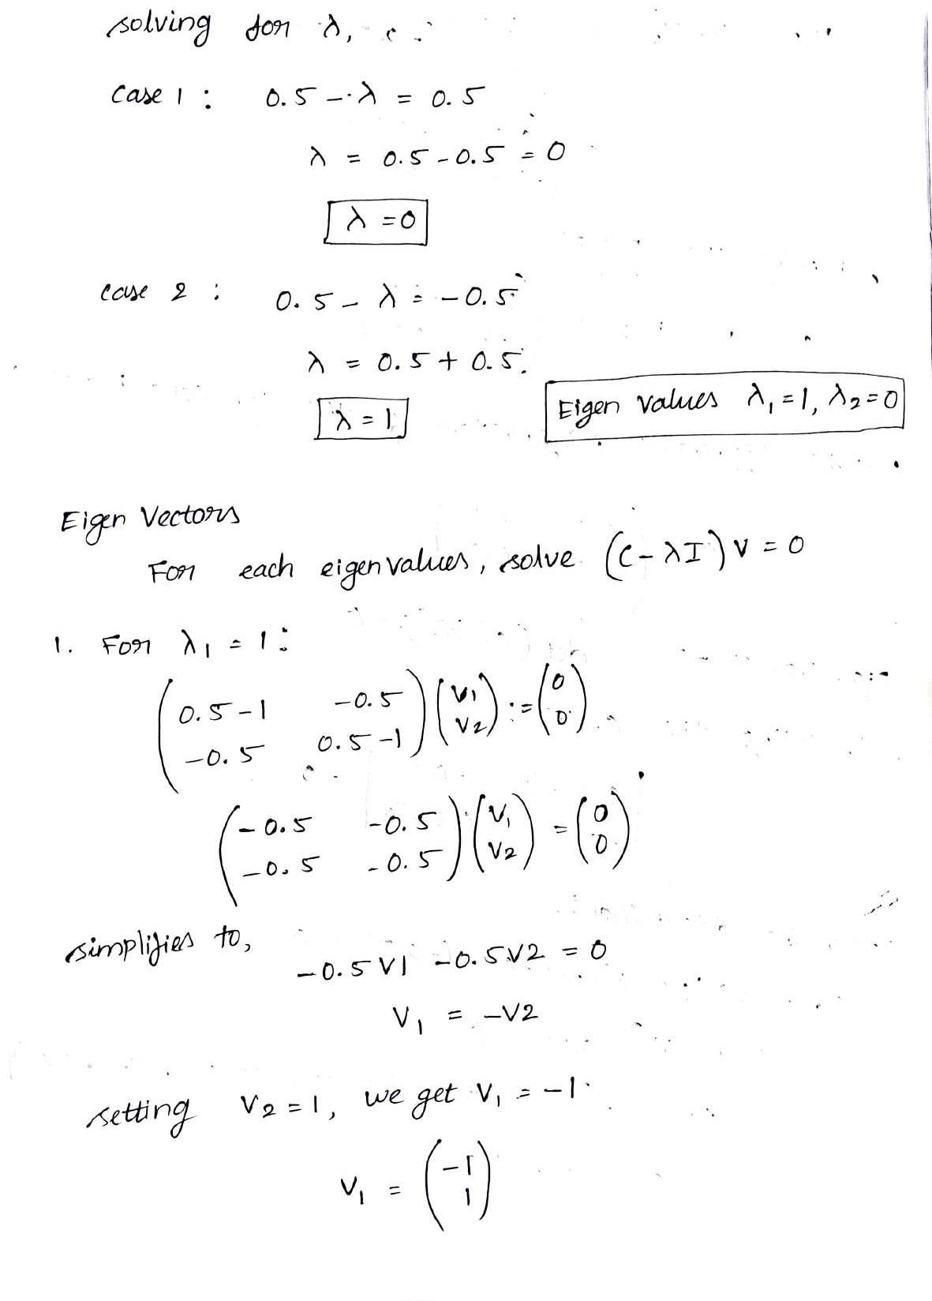

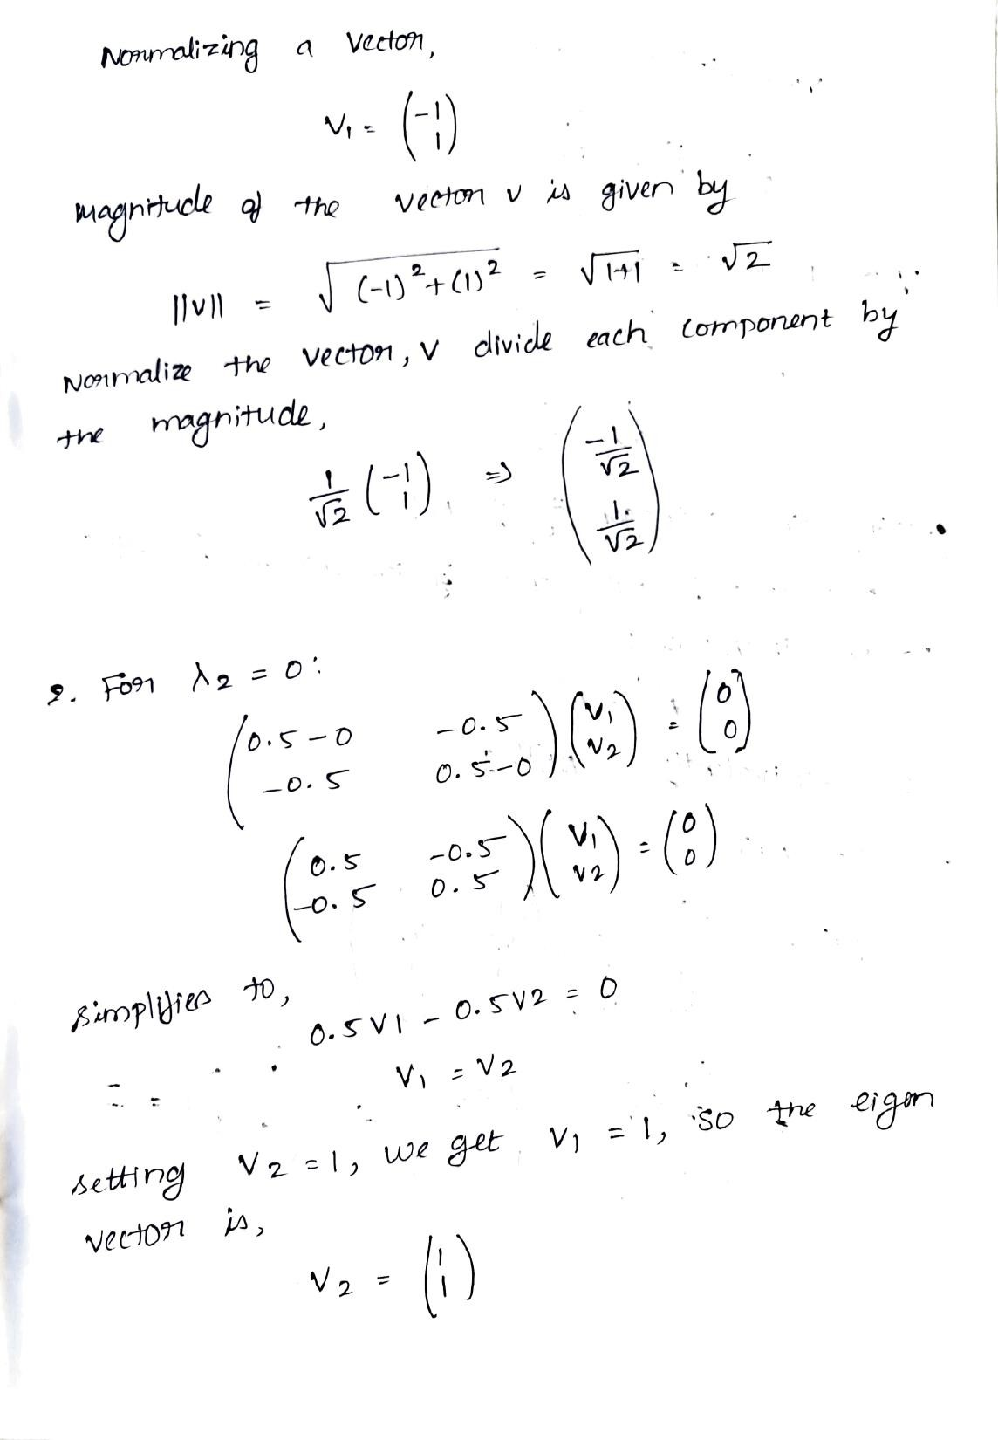

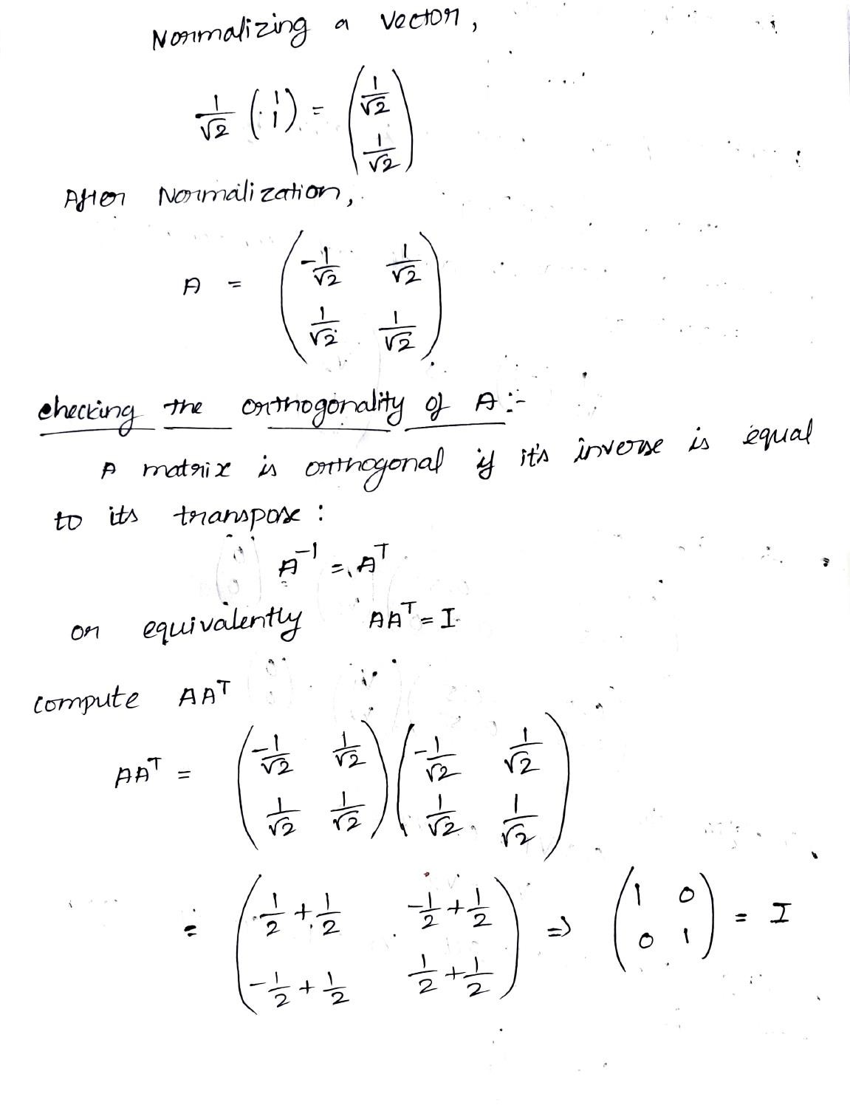

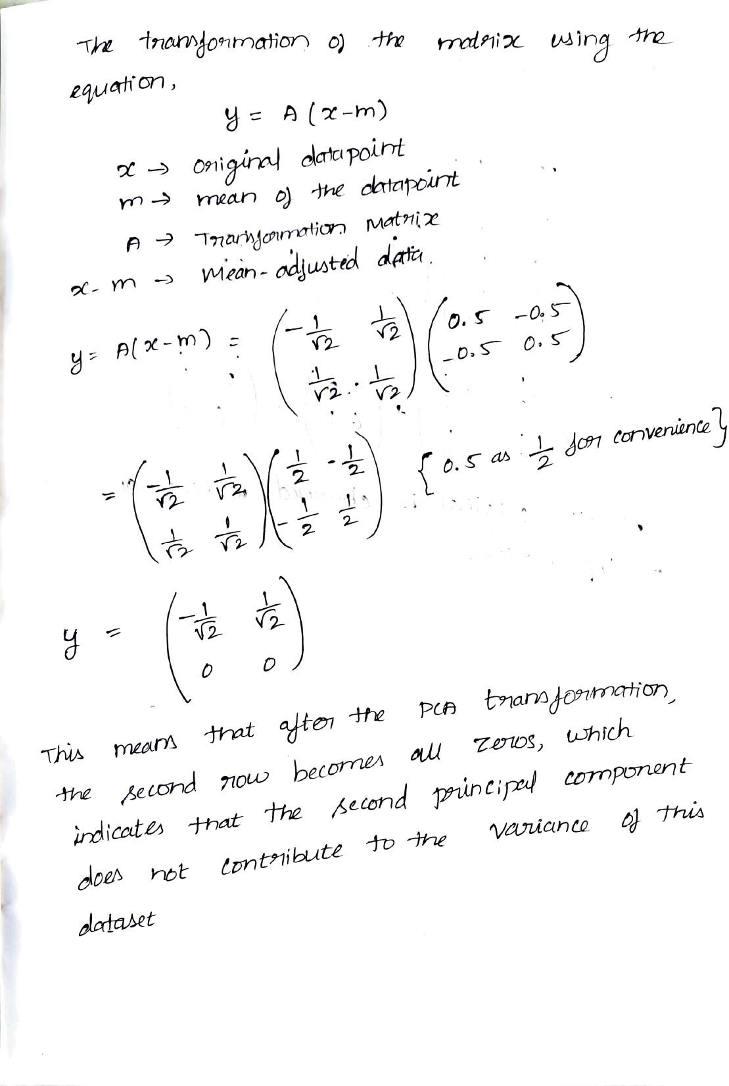

 | 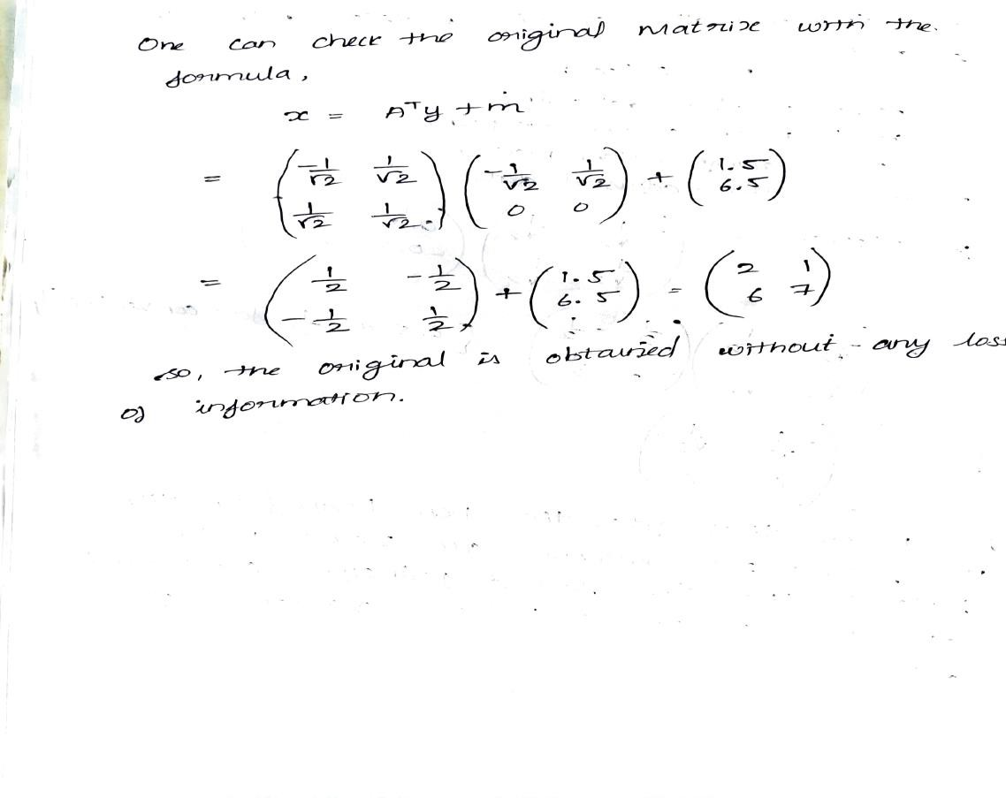
4a | Write the Find-S algorithm with a solved example for the same, and specify the limitations of Find-S.  Scheme: -  S Algorithm: -3 Marks  Example: -4 Marks  Ans:  Initialize ‘h’ to the most specific hypothesis. h = ⟨φ, φ, φ, φ, φ, …⟩  Generalize the initial hypothesis for the first positive instance. For each subsequent instance:  - If it is a positive instance:  - Check each attribute value in the instance with the hypothesis ‘h’.  - If the attribute value is the same as the hypothesis value, do nothing.  - If the attribute value is different from the hypothesis value, change it to ‘?’ in ‘h’.  - If it is a negative instance:  - Ignore it. | [07] | CO2 | L3

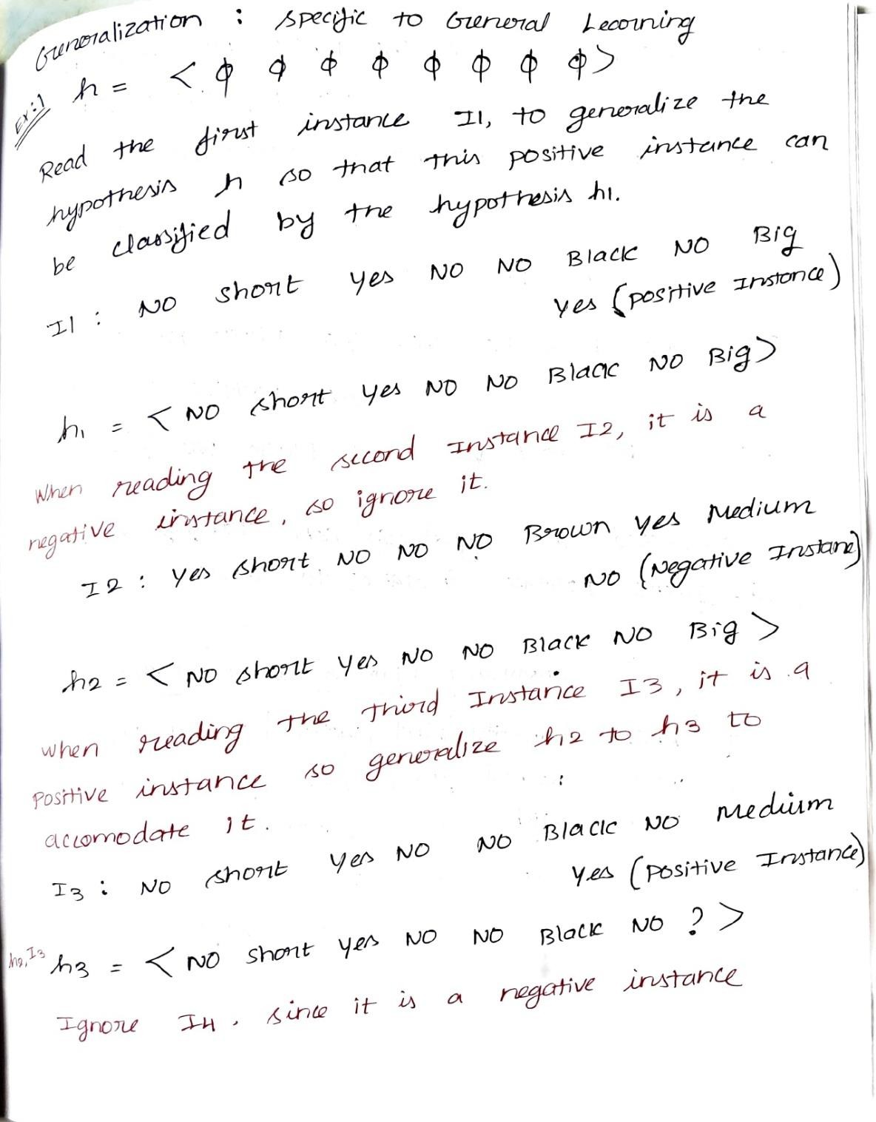

 | 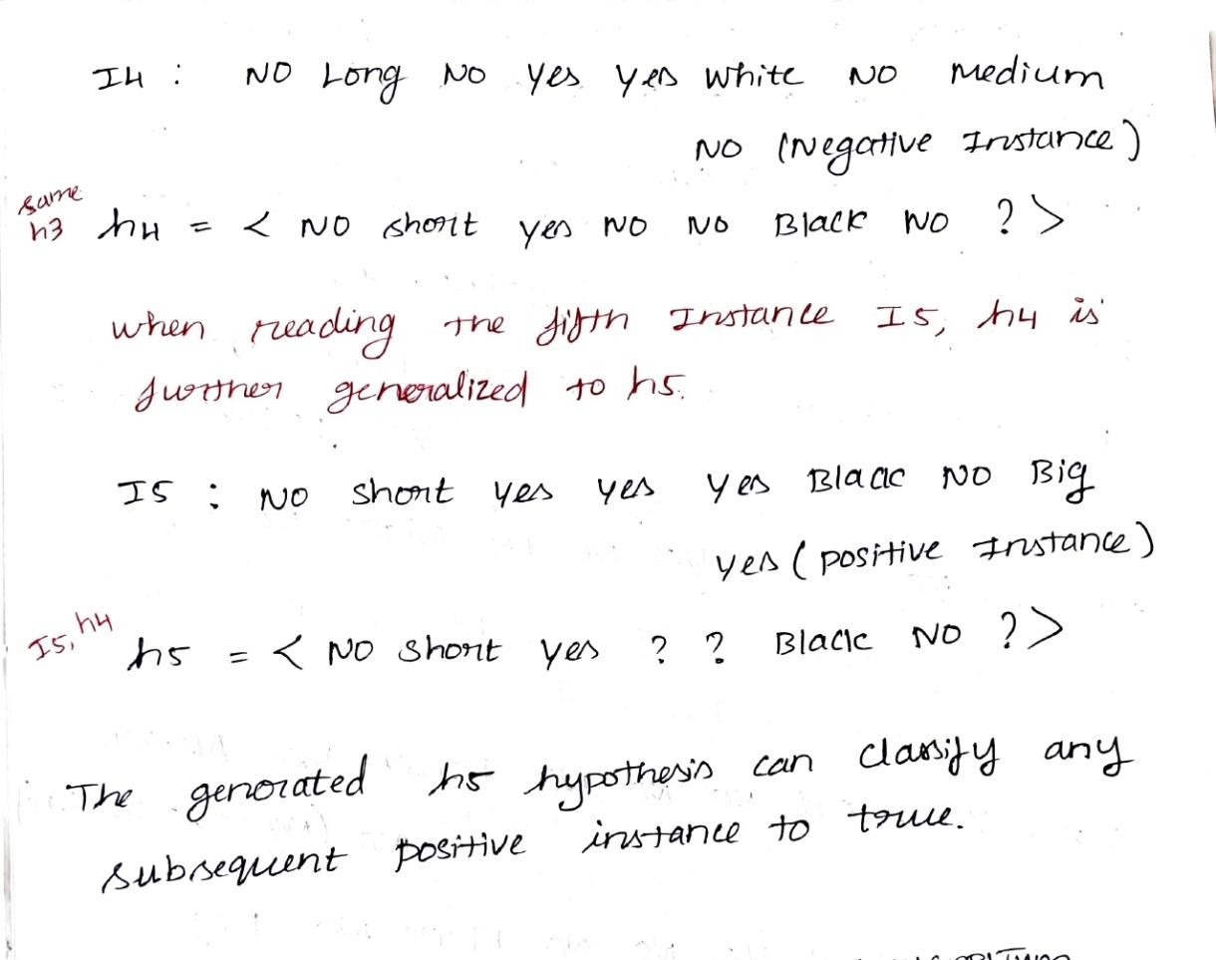
4b | Do the stem and Leaf plot for the following English Marks  {38, 53, 63, 82, 88, 83, 85,92}  Scheme: -  Steam and leaf plot: - 3 Marks  Ans: Stem | Leaf 38, 53, 63, 82, 83, 85, 88, 92  -- Stem | Leaf------------  3 | 8  5 | 3  6 | 3  8 | 2 3 5 8  9 | 2 | [03] | CO2 | L3
5a | Apply the Candidate Elimination algorithm for the training dataset below, which consists of 6 instances. Show the updated S and G boundaries after processing every instance.  Scheme: -  Solution step by step: -6 Marks  S & G Boundaries: - 2Markas  Sky AirTemp Humidity Wind Water Forecast EnjoySport Sunny Warm Normal Strong Warm Same Yes Sunny Warm High Strong Warm Same Yes Rainy Cold High Strong Warm Change No Sunny Warm High Strong Cool Change Yes  Ans: The Candidate Elimination algorithm works by maintaining two boundaries: the Specific boundary (S) and the General boundary (G). Initially, S is set to the most specific hypothesis ⟨Ø, Ø, Ø, Ø, Ø, Ø⟩ and G is set to the most general hypothesis ⟨?, ?, ?, ?, ?, ?⟩.  For the first training instance (Sunny, Warm, Normal, Strong, Warm, Same) with  output Yes, since it is a positive example, the specific boundary S is updated by replacing all Ø with the corresponding attribute values. Thus, S becomes ⟨Sunny, Warm, Normal, Strong, Warm, Same⟩, while G remains unchanged. | [08] | CO2 | L3

For the second positive instance (Sunny, Warm, High, Strong, Warm, Same), S is compared attribute-wise. Since the Humidity value differs (Normal and High), it is generalized to “?”. All other attributes remain the same. Hence, S becomes ⟨Sunny, Warm, ?, Strong, Warm, Same⟩ and G is still ⟨?, ?, ?, ?, ?, ?⟩.

The third instance (Rainy, Cold, High, Strong, Warm, Change) is a negative example. In this case, the general boundary G must be specialized so that it does not cover this negative instance but remains consistent with S. The minimal specializations produce hypotheses such as ⟨Sunny, ?, ?, ?, ?, ?⟩, ⟨?, Warm, ?, ?, ?, ?⟩, and ⟨?, ?, ?, ?, ?, Same⟩. The specific boundary S remains unchanged.

The fourth instance (Sunny, Warm, High, Strong, Cool, Change) is positive. The specific boundary S is updated again. Since the Water attribute (Warm and Cool) and Forecast attribute (Same and Change) differ, they are generalized to “?”. Thus, S becomes ⟨Sunny, Warm, ?, Strong, ?, ?⟩. From G, any hypothesis inconsistent with this positive example is removed, so ⟨?, ?, ?, ?, ?, Same⟩ is eliminated.

Finally, the version space is bounded by: Specific boundary S = ⟨Sunny, Warm, ?, Strong, ?, ?⟩ General boundary G = {⟨Sunny, ?, ?, ?, ?, ?⟩, ⟨?, Warm, ?, ?, ?, ?⟩}.
5b | Sorted data for price(in dollars): 2, 6, 7, 9, 13, 20, 21, 24, 30. Apply various Binning Techniques  Scheme: -  Binning Techniques: -1*2=2 Marks  Ans: 2, 6, 7, 9, 13, 20, 21, 24, 30  Number of observations (n) = 9  Create Bins  - Bin 1: 2, 6, 7  - Bin 2: 9, 13, 20  - Bin 3: 21, 24, 30  Calculate mean of each bin and replace values with mean.  - Bin 1 Mean: (2+6+7)/3 = 15/3 = 5  → 5, 5, 5  - Bin 2 Mean: (9+13+20)/3 = 42/3 = 14  → 14, 14, 14  - Bin 3 Mean: (21+24+30)/3 = 75/3 = 25  → 25, 25, 25  - Bin 1 Median: 6  → 6, 6, 6  - Bin 2 Median: 13  → 13, 13, 13  - Bin 3 Median: 24  Bin 1 Boundaries: 2 and 7  → 2, 7, 7  - Bin 2 Boundaries: 9 and 20  → 9, 9, 20  - Bin 3 Boundaries: 21 and 30  → 21, 21, 30  - → 24, 24, 24 | [02] | CO2 | L3
6a | Write the definition for the K-Nearest Neighbor (KNN) algorithm. Consider the following student performance training dataset:  Scheme: -  Step by step solution: -6 Marks  Formula & Final Answer: -2 Marks

 |  | S.No | CGPA | Assessment | Project | Result |  | [08] | CO3 | L3
 |  | 1 | 9 | 88 | 9 | Pass
 |  | 2 | 8.3 | 75 | 8 | Pass
 |  | 3 | 7.9 | 73 | 7 | Pass
 |  | 4 | 5.6 | 45 | 5 | Fail
 |  | 5 | 7 | 53 | 6 | Fail
 |  | 6 | 6.6 | 55 | 5 | Fail
 |  | 7 | 8.6 | 82 | 8 | Pass
 |  | 8 | 5.8 | 48 | 4 | Fail
 | K-Nearest Neighbour (KNN) is a non-parametric, instance-based learning algorithm used for both classification and regression. It works by finding the K closest training samples (neighbors) to a given test instance based on a distance measure (such as Euclidean distance).  - In classification, the test instance is assigned to the class that is most common among its K nearest neighbors (majority vote).  - In regression, the output is typically the average (or weighted average) of the values of its K nearest neighbors.  Using the K-Nearest Neighbour (KNN) algorithm with K = 3, classify the following test instance: (5.8,90,8)  Ans:  K = 3  We calculate Euclidean Distance:  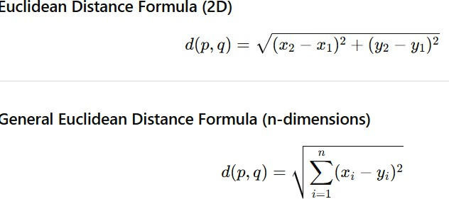 |  |  |  |  |  |  | [08] | CO3 | L3
 | Step 1: Compute Distances  S.No (CGPA, Assess, Result Distance from (5.8,90,8) Project)  1 (9,88,9) Pass √[(9−5.8)² + (88−90)² + (9−8)²] = √(10.24+4+  3.90  2 (8.3,75,8) Pass √(6.25+225+0)=√231.25 ≈ 15.21  3 (7.9,73,7) Pass √(4.41+289+1)=√294.41 ≈ 17.15  4 (5.6,45,5) Fail √(0.04+2025+9)=√2034.04 ≈ 45.10  5 (7,53,6) Fail √(1.44+1369+4)=√1374.44 ≈ 37.07  6 (6.6,55,5) Fail √(0.64+1225+9)=√1234.64 ≈ 35.13  7 (8.6,82,8) Pass √(7.84+64+0)=√71.84 ≈ 8.47 |  |  |  |  |  |  | [08] | CO3 | L3

 | 8 (5.8,48,4) Fail √(0+1764+16)=√1780 ≈ 42.19
Step 2: Select 3 Nearest Neighbours (K=3) Smallest distances:
- 3.90 → Pass (S.No 1)
- 8.47 → Pass (S.No 7)
- 15.21 → Pass (S.No 2)
Step 3: Majority Voting Among 3 nearest neighbors: Pass = 3
Fail = 0
6b | Write the Nearest centroid classifier algorithm  Scheme: -  Algorithm: - 2 Marks  Ans: separable.  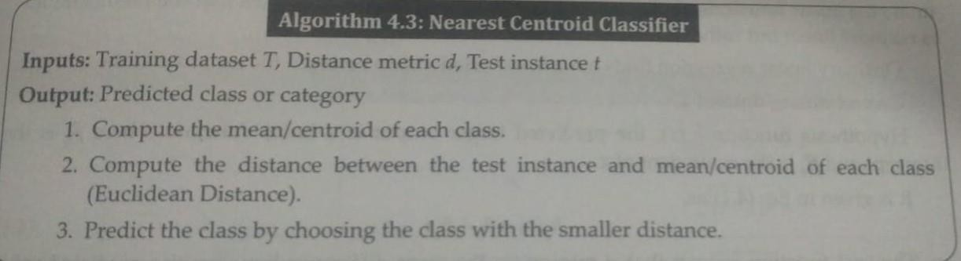 | [02] | CO3 | L1

